SCENARIO: | Consolidation Validation Report for 2022ACT and Period 12.
AREA: | Consolidation Validation Report | STATUS: | OPEN / APPROVED
Responsible | Diego Felipe Rozo | EXECUTION  DATE (MM/DD/YYYY): |  | 08/31/2023

SYSTEM DATA
SYSTEM | ENVIRONMENT | DATE LAST VERSION (MM/DD/YYY) | VERSION
TUP – CCH Tagetik | ABC Inc. | 10/05/2022 | 5.3.21.303

PRE-REQUISITE: | - To have the information of the individual balance sheets  - To have information on intercompany operations.  - Have the elimination rules established in the system.  - To have the FX rates

Table of Contents
1. Consolidation Validation Report 2
1.1. Explanation 2
1.1.1. The Balance Sheet: 2
1.1.2. The Income statement: 3
1.1.1. The Cash Flow: 5
1.1.2. Retained Eargings 6
1.1.3. Consolidation Area 6
1.1.4. FX Rates 7

- Consolidation Validation Report
  - Explanation

The Consolidation Validation Report is composed by;

- The Balance Sheet,
- The Income Statement,
- The Cash Flow (down to the lowest elements) with all categories in columns.
- A tab for the Retained Earnings carry forward (from the Previous Year and broken down with all variations) to validate that the carry forward was done correctly.
- An additional tab for the Consolidation Area (extracting the consolidation area as a query).
- And the last tab will be a recapitulation of the exchange rates (normal and reversed).
    - The Balance Sheet:

The consolidated balance sheet is a financial statement used to summarise and present the financial position of a group of related companies, usually under a parent company. Its main objective is to provide a complete and accurate picture of the financial health of the entire group rather than looking at each company individually.

The Balance Sheet in this report identifies all the Balance Sheet accounts defined in the Chart of Accounts and the entities of the business group with the currency of the entity and is also displayed in the currency established for consolidation, in this situation the Canadian dollar (CAD) currency and the $AMOUNT category. This helps to understand the situation for each company.

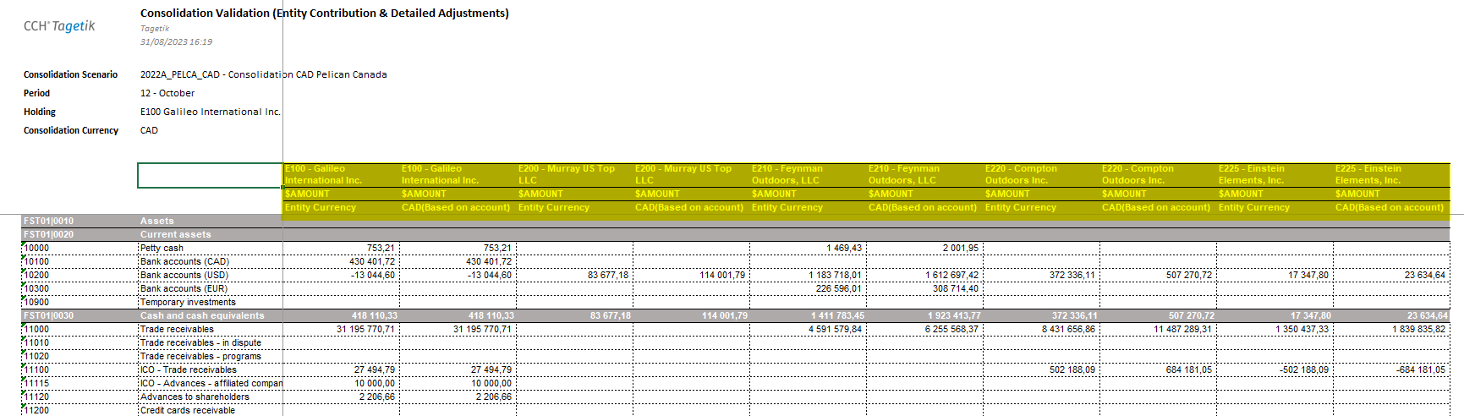

Next, you can see the view for the Business Group at the column level where the information of the different established categories appears (ENT_ADJ, IFRS_ADJ, RECLASS_IC, FI_ELIM) and finally the Total Consolidation column.

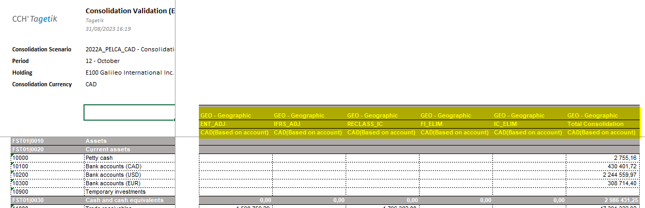

    - The Income statement:
A financial statement that summarises the revenues, expenses and profit or loss of a group of related companies, usually under a parent company, over a specified period of time, such as a quarter or a year. The primary objective of the consolidated P&L is to provide a complete and accurate picture of the profitability and financial performance of the entire group rather than looking at each company individually.

On the income statement sheet, we can observe that it maintains the same structure as the balance sheet, except that in this case, the view is for all the P&L accounts established in the chart of accounts.

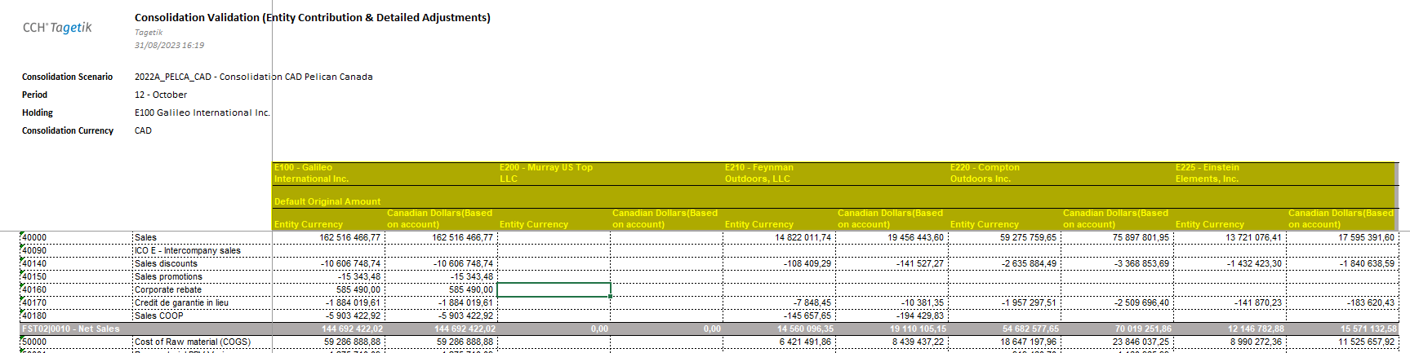

And after the information shown in the first part, we can also see at column level all the information for the corporate group with their respective categories of (ENT_ADJ, IFRS_ADJ, RECLASS_IC, FI_ELIM) and the last column as Total consolidation.

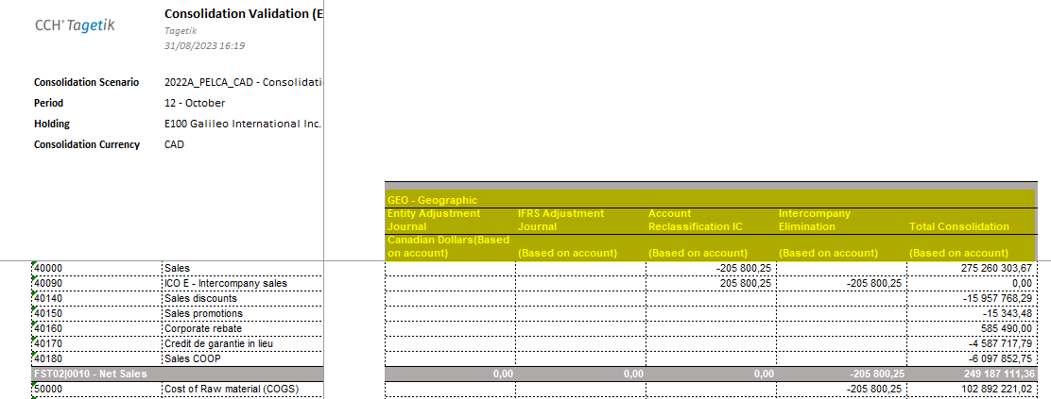

In case consolidation is handled at a detail level such as (product, business line, segment etc), it is necessary to enable custom dimension 2. This is the only dimension that can be used as counterpart dimension, apart from the entity dimension. For this case, the view of the consolidation validation report is similar, only with the detail view of dimension 2.

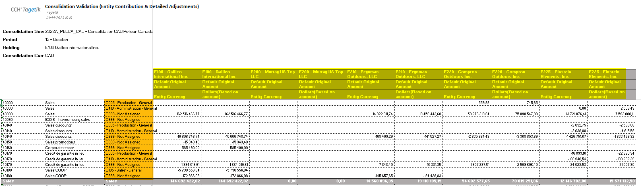

    - The Cash Flow:
Cash flow is defined as the variation of cash inflows and outflows in a given period and its information allows to measure the financial health of the company. Cash flow allows for forecasting, good financial management and decision making and income control, with the aim of improving profitability for the company.

Under this information, we can relate the cash flow statement showing the cash used in (operating activities, investing activities and financing activities) in order to reconcile opening and closing balances for that period.

In the view of the cash flow report we can see that it is found under the Items operating activities where it is related to a specific list of (variation) accounts that allows to see their respective amounts. This is the same for the other items (investing and financing activities). At the column level we can find the companies that are part of the group with currency of the entity, currency of consolidation (CAD) and the $AMOUNT category.

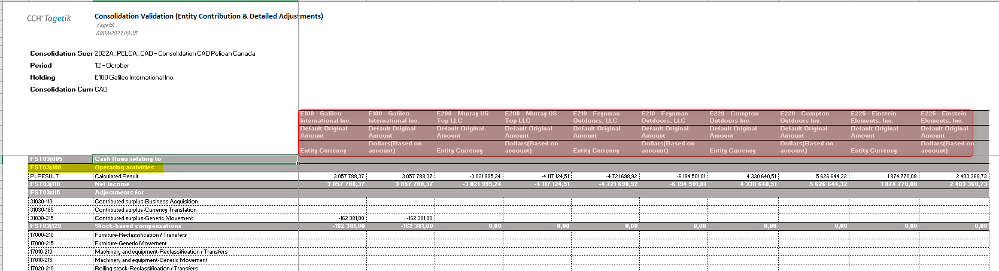

The following section shows the columns for the group, the categories mentioned above (ENT_ADJ, IFRS_ADJ, FI_ELIM, IC_ELIM) and the total consolidated column.

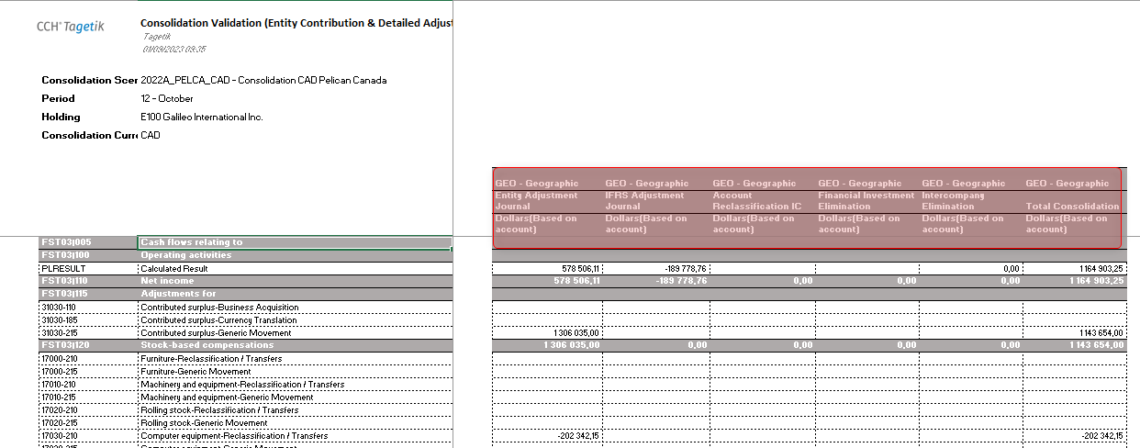

    - Retained Eargings
Retained earnings are a key account in the consolidation of financial statements as they represent the accumulated equity of all group companies. By eliminating appropriate adjustments and reflecting them accurately in the consolidated financial statements, they provide an accurate picture of the financial health and investment capacity of the group as a whole, which is essential for informed decision-making by investors and other stakeholders.
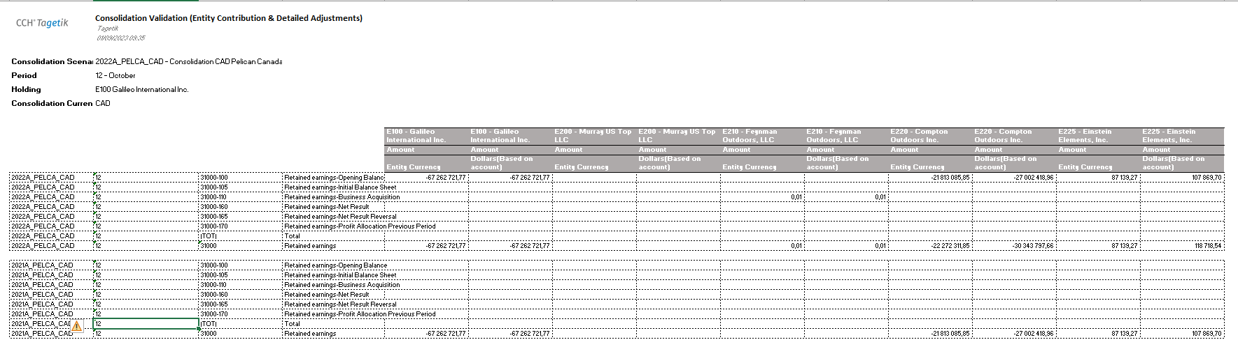

    - Consolidation Area

The Consolidation Area is used to define and manage the different groups of entities that a company needs to consolidate in its financial reporting. In other words, it allows an organisation to set up and manage different consolidation areas, each of which represents a specific group of related entities or companies that need to be consolidated in its financial statements.

The following report shows the consolidation area of the group, where the percentage shareholding of each group and nd the equity ratio percentage are determined.

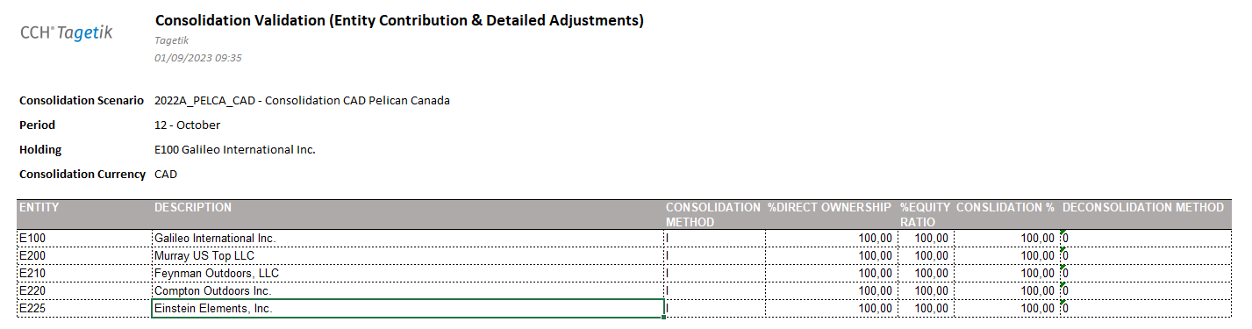
    - FX Rates
"FX Rates" refers to the exchange rates (also known as (foreign exchange rates) used to convert financial figures from one currency to another. These exchange rates are essential for companies operating in multiple currencies, as they allow for accurate financial consolidation and financial reporting in a common currency, such as the US dollar or euro.

A step-by-step document is attached below.

Failed: Corrected, failed and approved:

We, the RCGT team, confirm that the expected result was obtained in the execution of this and we consider this approved.

NAME | ROL | SIGNATURE

